**Naam Product Productgroep**

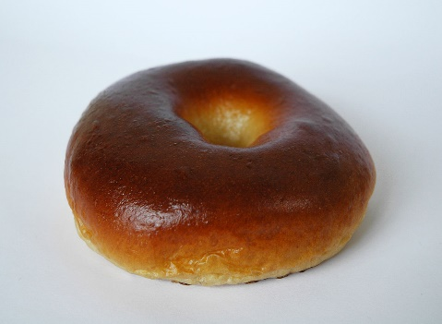

Afbeelding

|  |  |
| --- | --- |
| **Ingrediënten** | **Bakschema** |
| |  |  |  |  | | --- | --- | --- | --- | |  | g |  | % | |  | g |  | % | |  | g |  | % | |  | g |  | % | |  | g |  | % | |  | g |  | % | |  | g |  | % | |  |  |  |  | | **Vulling:** | |  |  | |  | g |  | % | |  | g |  | % | |  | g |  | % | |  | g |  | % | | |  |  |  | | --- | --- | --- | | Deegtemperatuur | - |  | | Afweeggewicht | - |  | | Uitkomst | - |  | | Kneedtijd | - |  | | Rijzen | - |  | | Baktemperatuur | - |  | | Baktijd | - |  | | Uitroldikte | - |  | |
| **Werkwijze** | **Aandachtspunten** |
| |  |  | | --- | --- | | - |  | | - |  | | - |  | | - |  | | - |  | | - |  | | - |  | | - |  | | - |  | | - |  | | - |  | |  |  | |  |  | |  |  | |  |  | |  |  | | |  |  | | --- | --- | | - |  | | - |  | | - |  | | - |  | | - |  | | - |  | | - |  | | - |  | | - |  | | - |  | | - |  | |  |  | |  |  | |  |  | |  |  | |